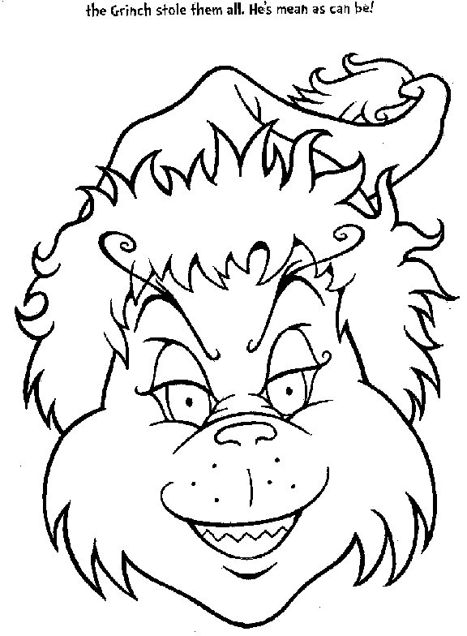
“The Grinch
Who Stole Christmas”

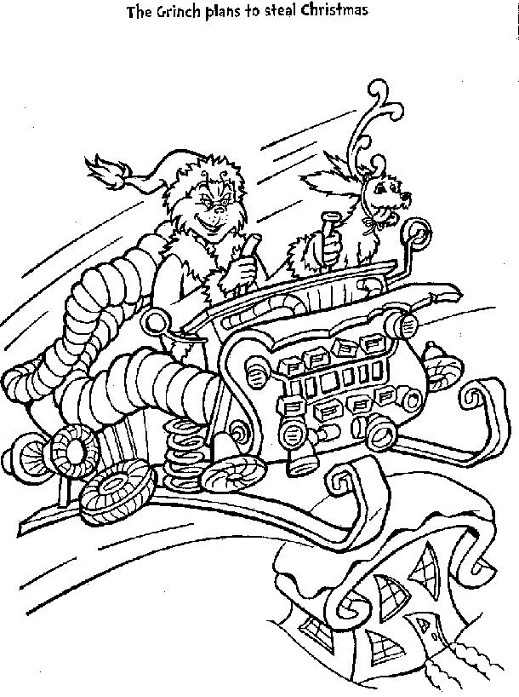

Who was the real cruel being who tried
to ruin the first Christmas?

__________ __________ _________ _________ ____________
What did God promise to send to rescue us from the devil?
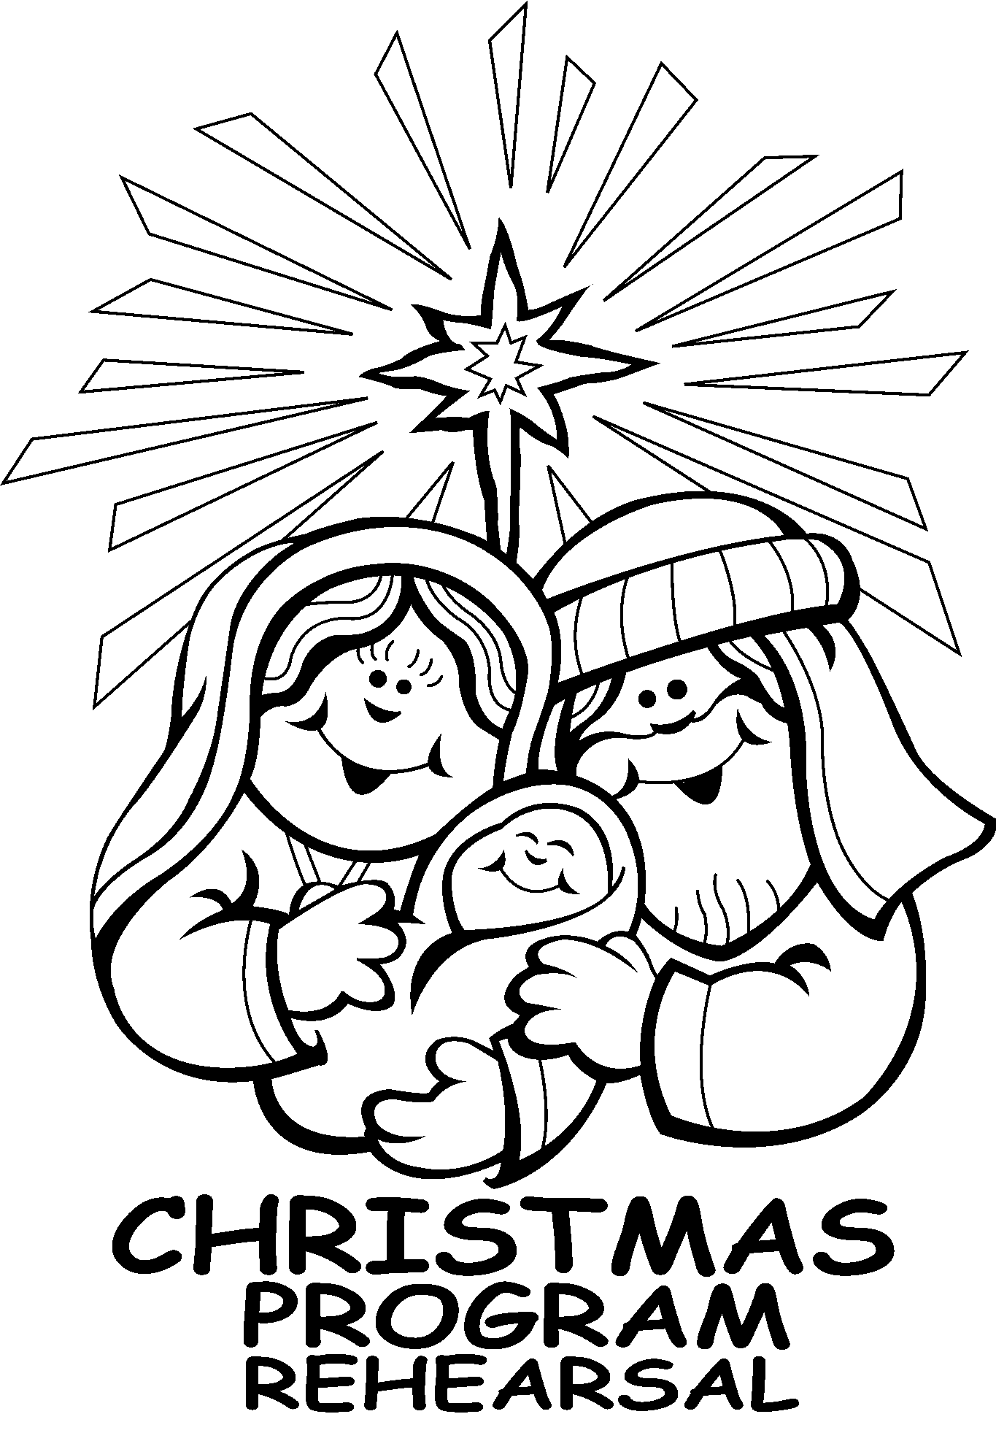

A _________ __________ __________ ___________ _________ __________ !
The devil tried many times to ruin God’s plans. He tried to prevent Christmas from ever happening in the first place. Who was one of the men he used to try to do this?

_________ __________ __________ __________ _________ __________ __________
Nobody can stop God from doing what he wants. Who did he send to be our Savior?

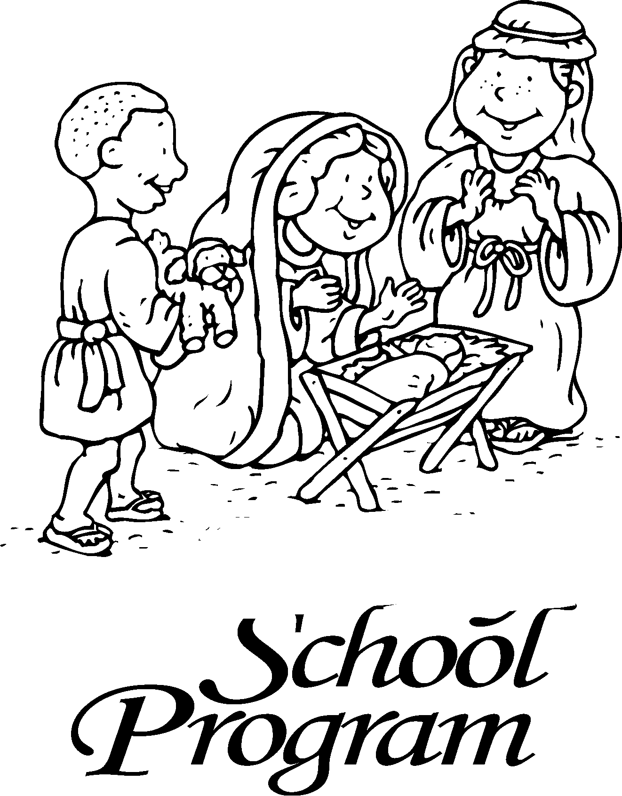

____________ _____________ _____________ _____________ ____________

Even though Jesus was born, the devil still tried to ruin Christmas. He used the ruler of Israel at the time to try to kill baby Jesus. What was that king’s name?

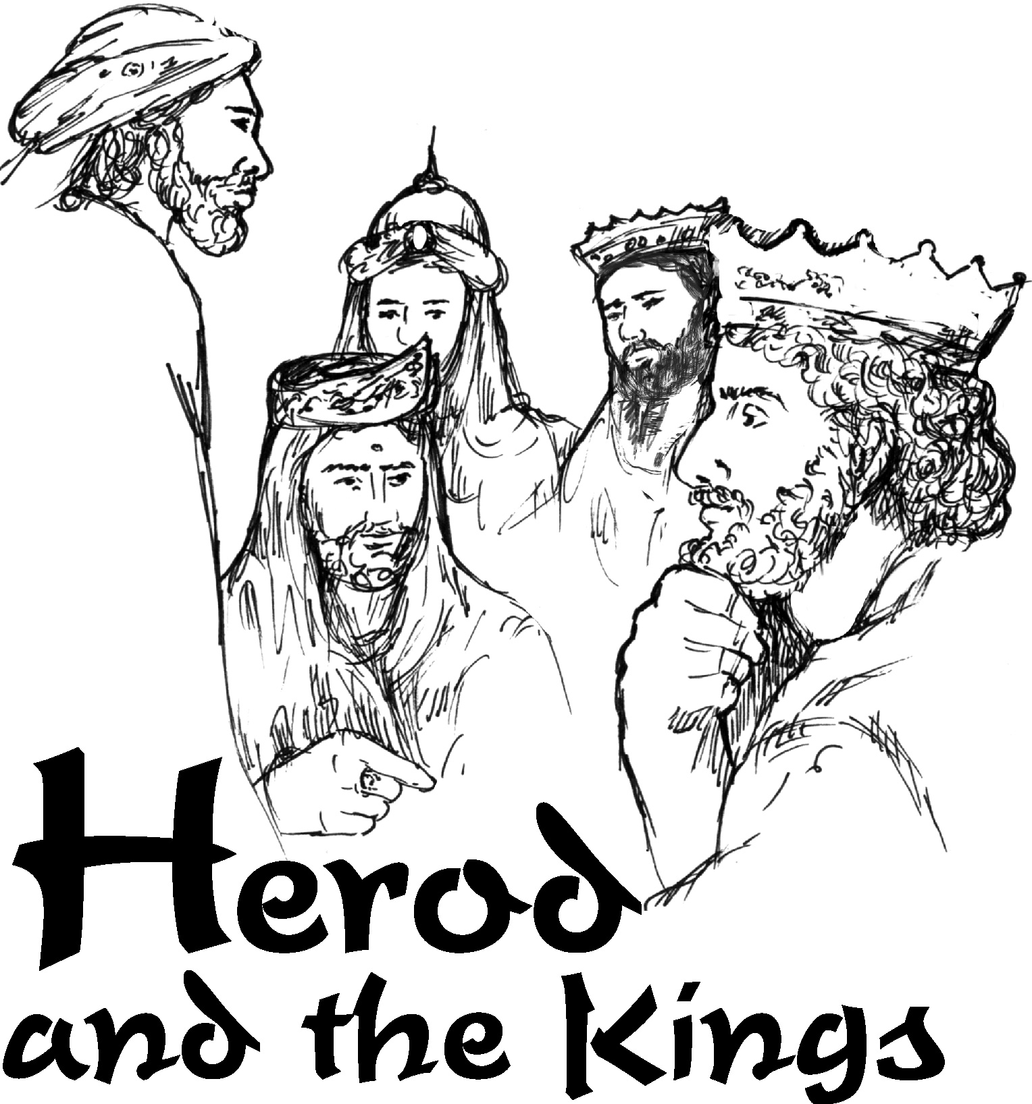

____________ _____________ ____________ _____________ ____________

Jesus is Our Savior from Sin and the Devil
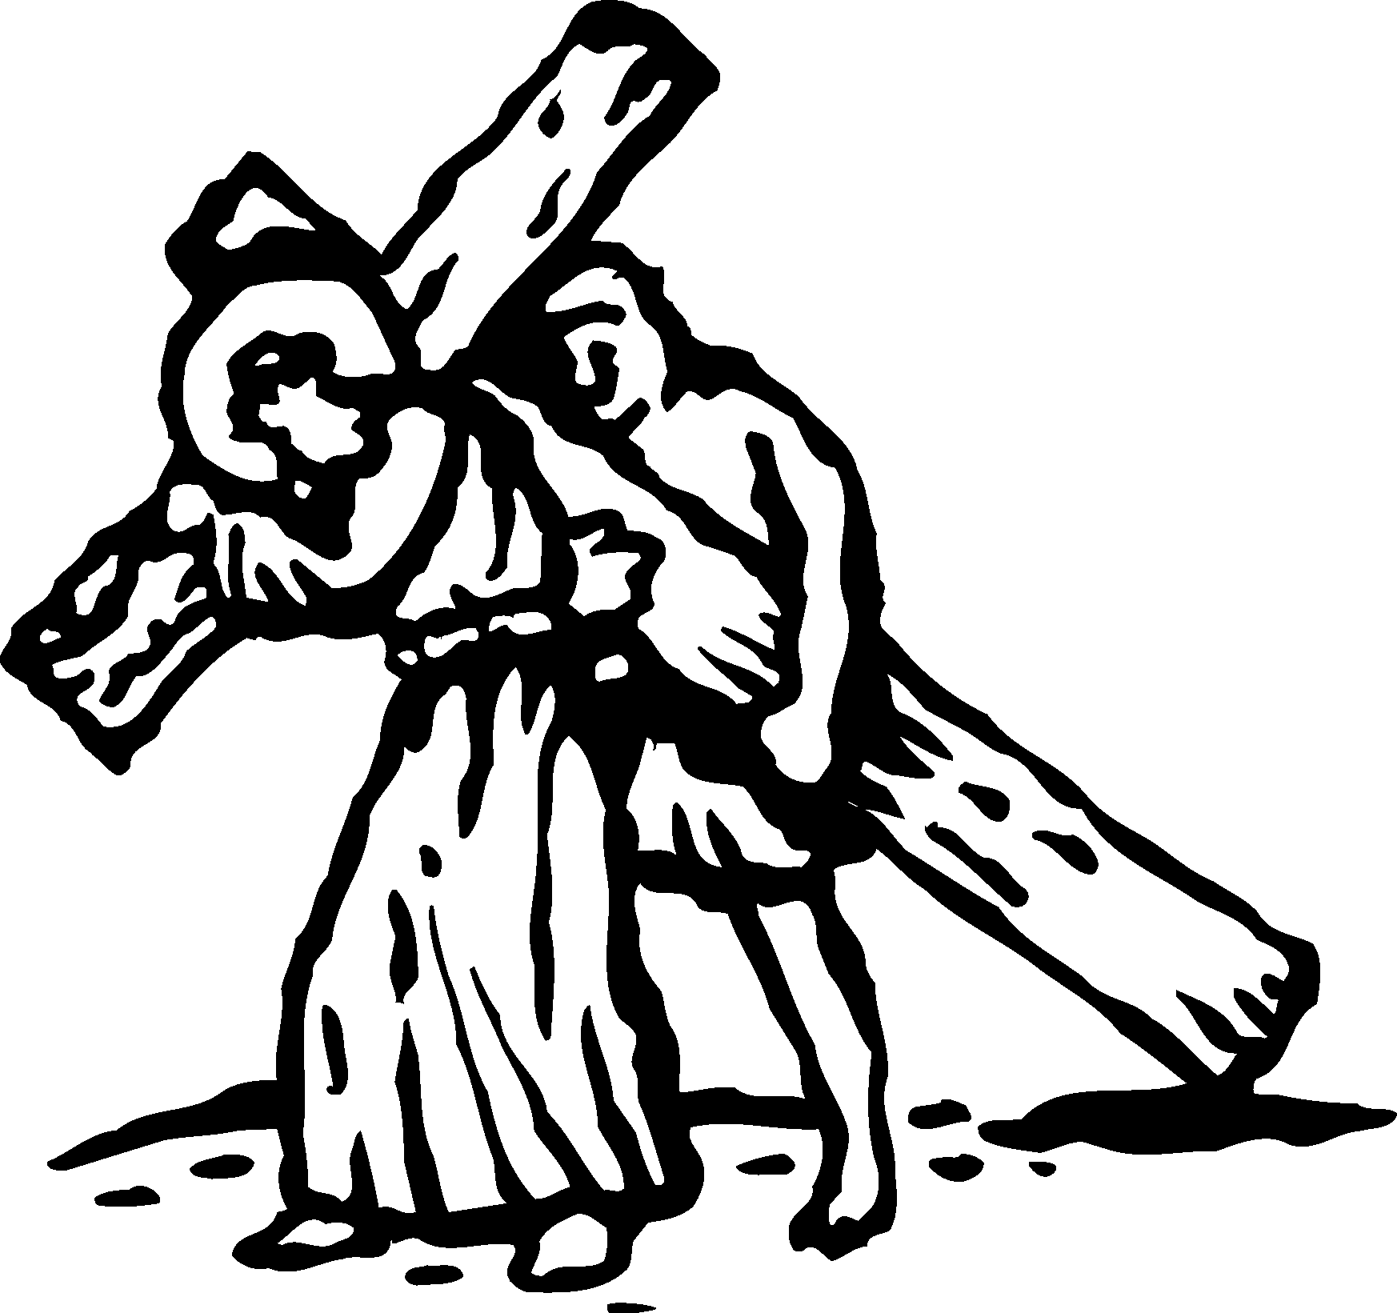
The devil thought he had killed Jesus on the cross.

When did Jesus prove he had beaten the devil for us once and for all?

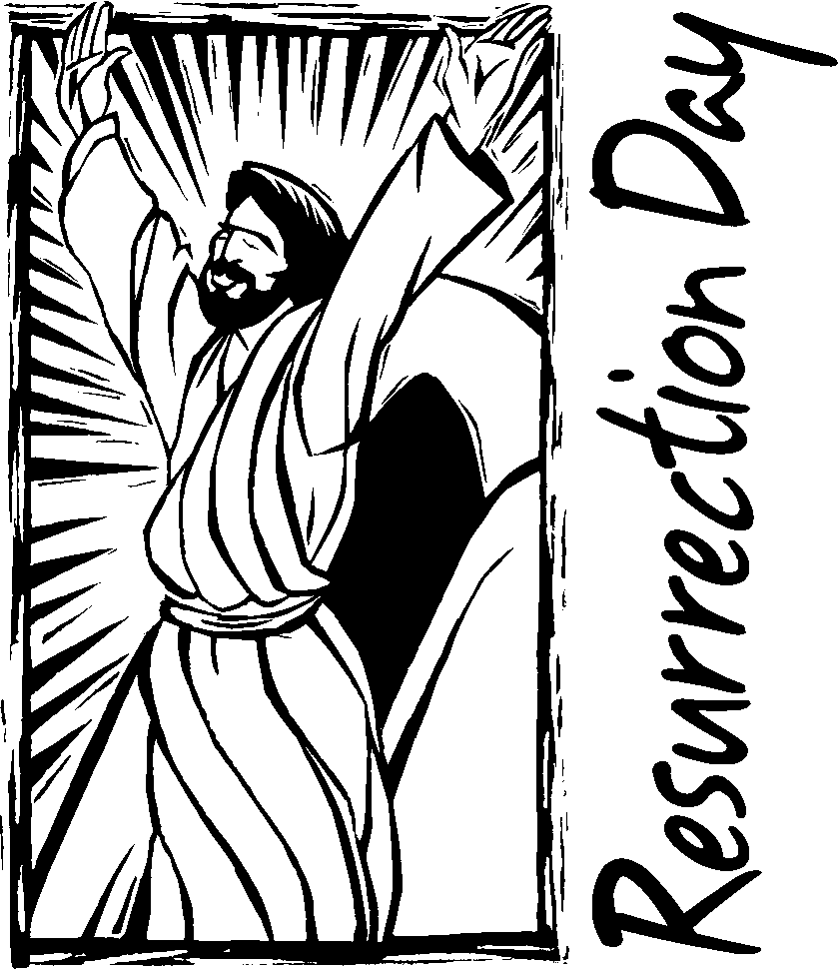

_______ _______ _______ _______ ________ ________

What does Jesus’ victory over the devil mean for us?
Do we have to be afraid of him?

NO!



