NAME ________________________________

What is a holiday?

Here are a few holidays we celebrate every year. What are they? Circle your favorite holiday.


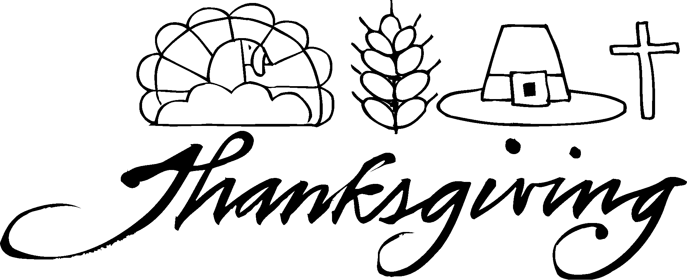


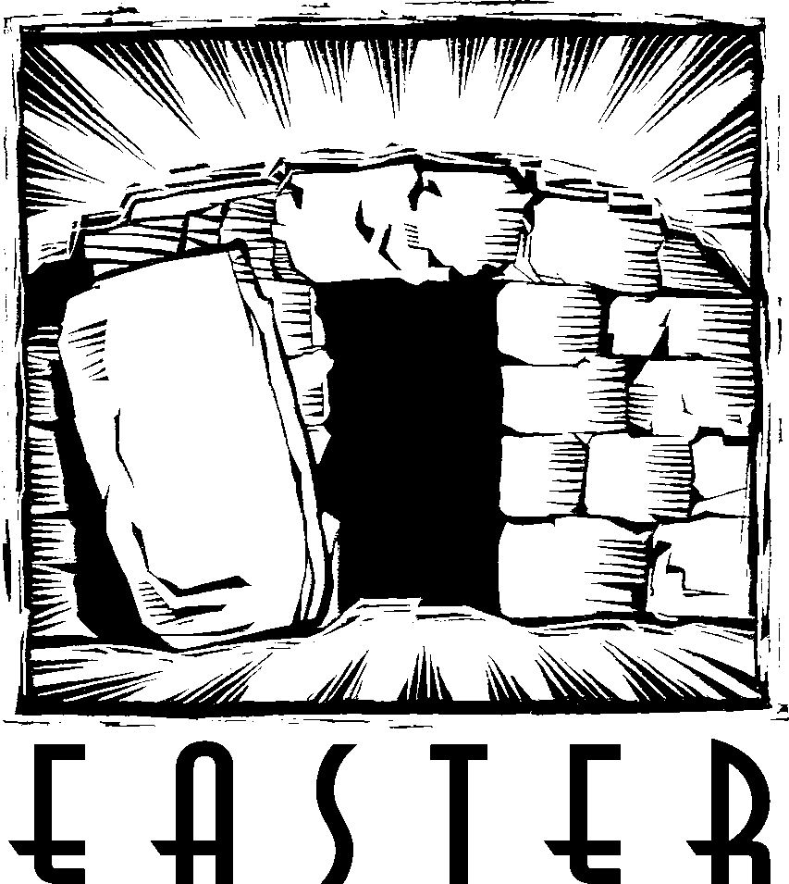

People use the word “holiday” to describe just about any special occasion that our country celebrates (and we get school off for!). But did you know the word “holiday” used to mean something even more special than that? The word “holiday” is a combination of two words. Fill in the blanks below with those two words.

______ ______ ______ ______ - ______ ______ ______

What is the very special “holy-day” we celebrate this time of year?

What makes this day so special? Whose birth do we celebrate on this day?

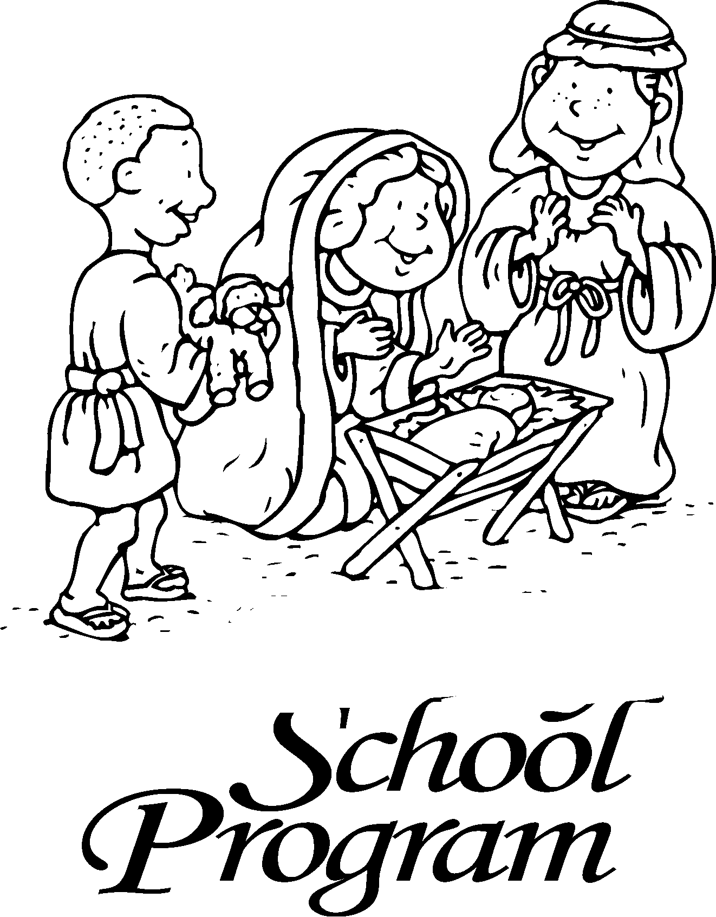

____________ _____________ _____________ _____________ ____________
YOU ARE NOT HOLY

God expects you to be holy. This means to have NO . . .

_________ __________ __________!

Draw a picture or two of some of the sins you have committed.

God loves us so much that instead of making us suffer the consequences of our sins, he promised to send a Savior to rescue us from our sins.

"[Mary] will give birth to a son, and you are to give him the name Jesus, because he will save his people from their sins."

(Matthew 1:20)

JESUS IS HOLY

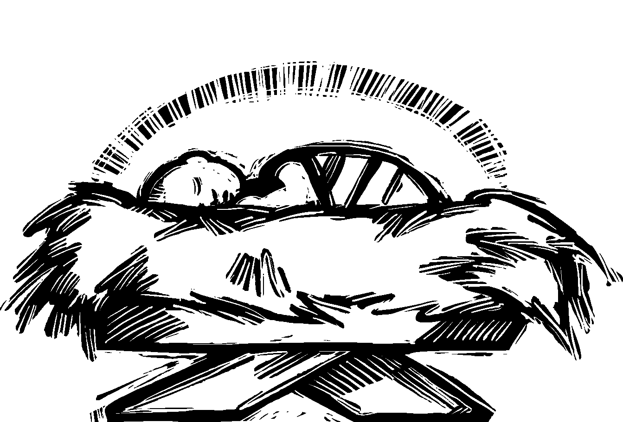
God kept his promise to send us a Savior to rescue us from our sins. Listen to the account of the night Jesus was born.

Jesus is the only person ever born who was holy. Whose Son was Jesus?

__________ _________ __________ ‘__________
JESUS MAKES YOU HOLY

Jesus was born to take away your sins and make you holy. How did he do that?

“We have been made holy through the sacrifice of the body of Jesus Christ once for all.”
(Hebrews 10:10)
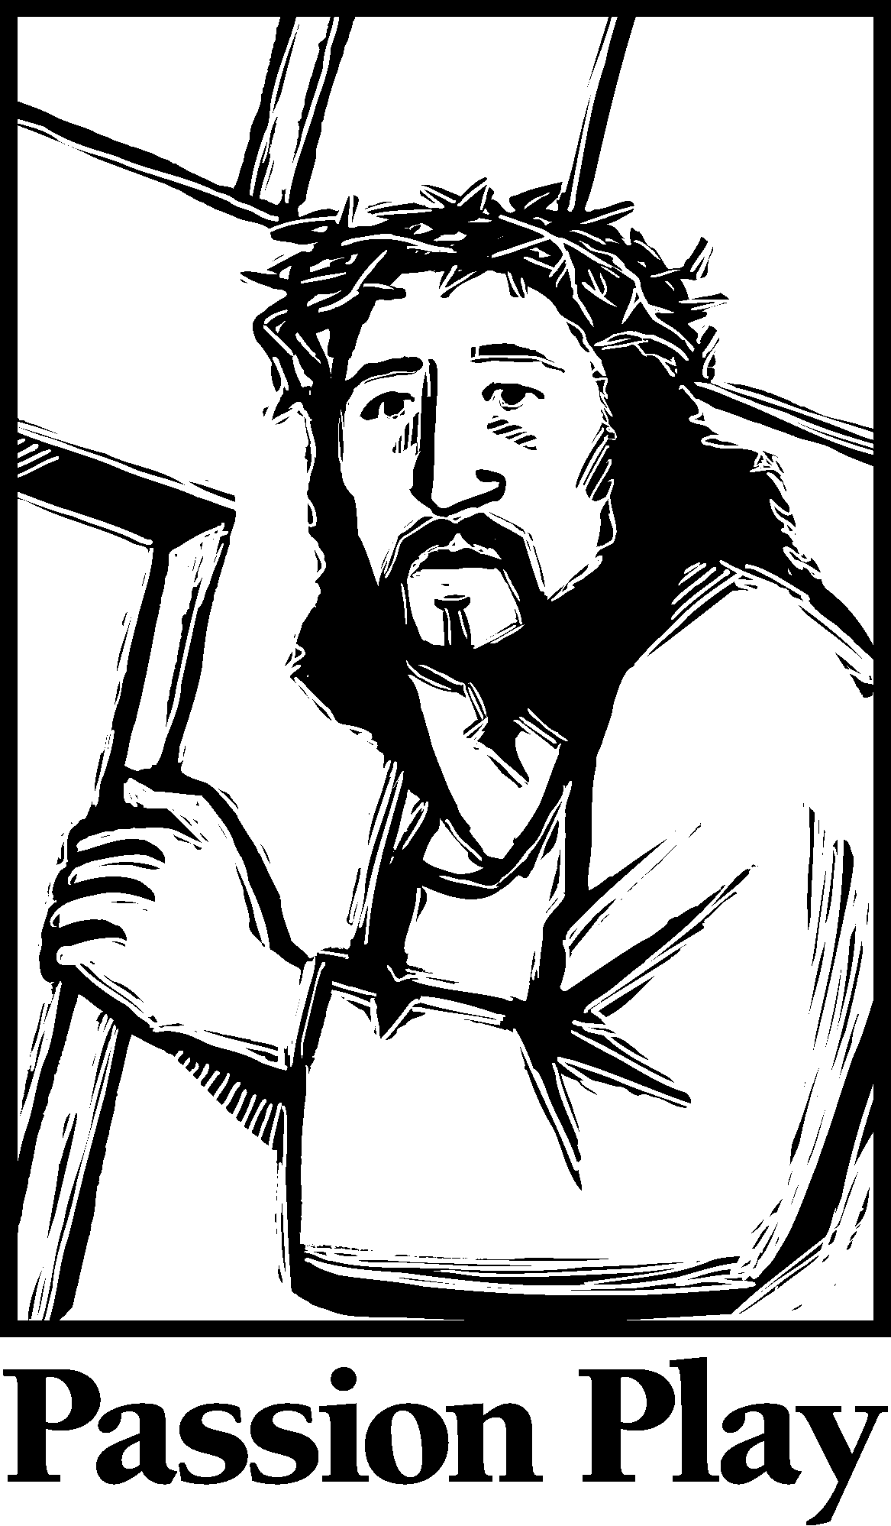

Jesus died on the . . .

____________ _____________ _____________ _____________ ____________
What did God use to wash away all your sins and make you holy?

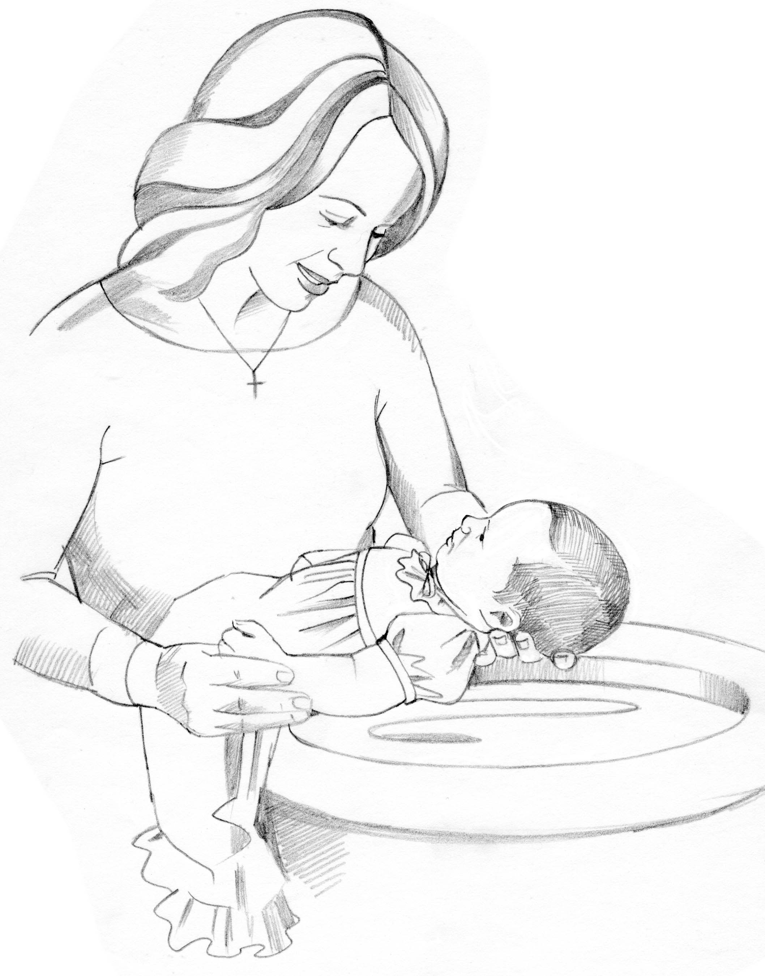

_________ __________ __________ __________ _________ _________ __________

“I am the LORD, who makes you holy.”
(Exodus 31:13)

Jesus makes

__________ __________ __________ __________ ___________

day holy!

Draw a picture of how this makes you feel.

