
Have you ever seen the movie, “The Grinch Who Stole Christmas”?
What did the Grinch do?

How were his plans ruined?

The Grinch is a make-believe character in a fairy tale story. But did you know that there was a real, cruel individual who did try to ruin the first Christmas? Who was he?

Why was Christmas necessary in the first place? When did God first promise that he would send his Son to this earth?

What would he come to do?

To whom did God make this promise?

So the Lord God said to the serpent, “Because you have done this, “Cursed are you above all the livestock and all the wild animals! You will crawl on your belly and you will eat dust all the days of your life. And I will put enmity between you and the woman, and between your offspring and hers; he will crush your head, and you will strike his heel.”
(Genesis 3:14-15)

Many, many years later (around 700 B.C. – 2,700 years ago!) a man named Isaiah (a prophet) lived and worked for God among God's people. God told Isaiah things which would happen many years later. One of those things God told Isaiah about was the birth of a baby boy, who is more than just a human being.

Who did God tell Isaiah this baby would be?

"For to us a child is born, to us a son is given,
and the government will be on his shoulders.
And he will be called Wonderful Counselor, Mighty God,
Everlasting Father, Prince of Peace."
(Isaiah 9:6)

There was another man who lived at the same time Isaiah lived and worked. His name was Micah. God also told Micah some things about the baby who would be born. Where did God tell Micah this baby would be born?

"But you, Bethlehem Ephrathah, though you are small among the clans of Judah, out of you will come for me one who will be ruler over Israel,
whose origins are from of old, from ancient times."

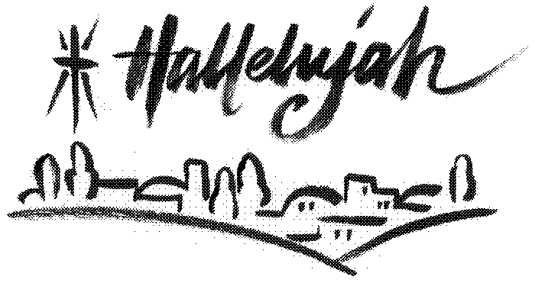

Does anyone know where this little town of Bethlehem is?
God has his plans for rescuing us from the devil. But the devil tried to ruin God’s plans. He tried to prevent Christmas from ever happening in the first place. Here are just a few examples of how he tried to stop Christmas . . .

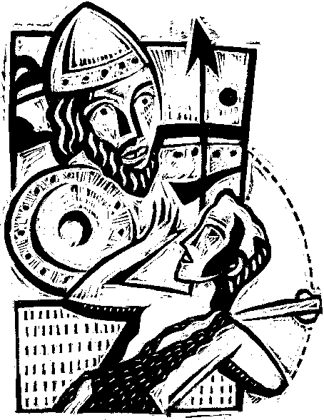

- Putting God’s people, and Jesus’ great, great, great . . . grandparents into slavery in Egypt and killing the baby boys!

- King Saul and the mighty Goliath (and many others) tried to kill Jesus’ great, great, great . . . grandfather, King David!

- Powerful nations like the Assyrians and the Babylonians tried to destroy Jesus’ family line!

Psalm 2

¹ Why do the nations conspire and the peoples plot in vain?
² The kings of the earth take their stand and the rulers gather together
against the Lord and against his Anointed One.
³ “Let us break their chains,” they say, “and throw off their fetters.”
⁴ The One enthroned in heaven laughs; the Lord scoffs at them.
⁵ Then he rebukes them in his anger and terrifies them in his wrath, saying, ⁶ “I have installed my King on Zion, my holy hill.”

Were any of these people or nations or the devil successful in stopping Christmas from coming? Why not?

Let's read about Jesus’ birth . . .

The Birth of Jesus

Luke 2:4-7

4 So Joseph also went up from the town of Nazareth in Galilee to Judea, to Bethlehem the town of David, because he belonged to the house and line of David. 5 He went there to register with Mary, who was pledged to be married to him and was expecting a child. 6 While they were there, the time came for the baby to be born, 7 and she gave birth to her firstborn, a son. She wrapped him in cloths and placed him in a manger, because there was no room for them in the inn.

Where did Joseph and Mary go? Why?

Where were they forced to spend the night?

What happened while they were there?

What was Jesus' first bed? What were his first clothes?

Luke 2:8-14

8 And there were shepherds living out in the fields nearby, keeping watch over their flocks at night. 9 An angel of the Lord appeared to them, and the glory of the Lord shone around them, and they were terrified. 10 But the angel said to them, "Do not be afraid. I bring you good news of great joy that will be for all the people. 11 Today in the town of David a Savior has been born to you; he is Christ the Lord. 12 This will be a sign to you: You will find a baby wrapped in cloths and lying in a manger."
13 Suddenly a great company of the heavenly host appeared with the angel, praising God and saying, 14 "Glory to God in the highest, and on earth peace to men on whom his favor rests."

What is a shepherd? Where were they and their sheep that night?

Whom did they suddenly see? What did the angel(s) tell them had happened?

Luke 2:15-20

15 When the angels had left them and gone into heaven, the shepherds said to one another, "Let's go to Bethlehem and see this thing that has happened, which the Lord has told us about." 16 So they hurried off and found Mary and Joseph, and the baby, who was lying in the manger. 17 When they had seen him, they spread the word concerning what had been told them about this child, 18 and all who heard it were amazed at what the shepherds said to them. 19 But Mary treasured up all these things and pondered them in her heart.
20 The shepherds returned, glorifying and praising God for all the things they had heard and seen, which were just as they had been told.

What did the shepherds want to do when the angels went back into heaven?

What did the shepherds do after they saw Jesus?

Even though Jesus was born, the devil still tried to ruin Christmas. He used the ruler of Israel at the time to try to kill baby Jesus. Let's read about it . . .

Matthew 2

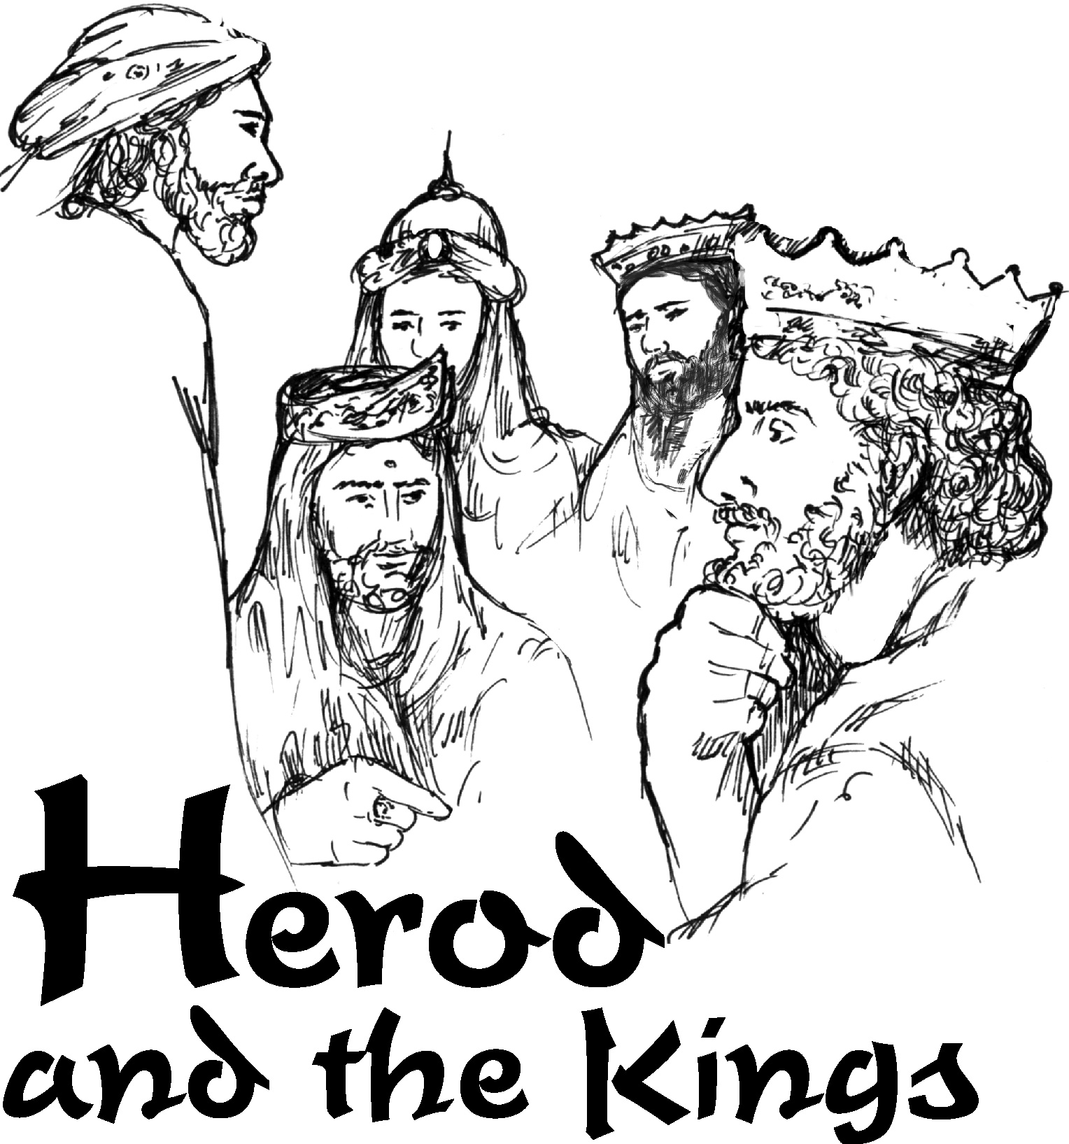
¹ After Jesus was born in Bethlehem in Judea, during the time of King Herod, Magi from the east came to Jerusalem ² and asked, "Where is the one who has been born king of the Jews? We saw his star in the east and have come to worship him." ³ When King Herod heard this he was disturbed, and all Jerusalem with him. ⁴ When he had called together all the people’s chief priests and teachers of the law, he asked them where the Christ was to be born. ⁵ “In Bethlehem in Judea,” they replied, “for this is what the prophet has written: ⁶ “‘But you, Bethlehem, in the land of Judah, are by no means least among the rulers of Judah; for out of you will come a ruler who will be the shepherd of my people Israel.’” ⁷ Then Herod called the Magi secretly and found out from them the exact time the star had appeared. ⁸ He sent them to Bethlehem and said, “Go and make a careful search for the child. As soon as you find him, report to me, so that I too may go and worship him.”
⁹ The star they had seen in the east went ahead of them until it stopped over the place where the child was. ¹⁰ When they saw the star, they were overjoyed. ¹¹ On coming to the house, they saw the child with his mother Mary, and they bowed down and worshiped him. Then they opened their treasures and presented him with gifts of gold and of incense and of myrrh. ¹² And having been warned in a dream not to go back to Herod, they returned to their country by another route.
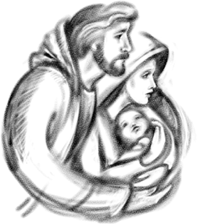
¹³ When they had gone, an angel of the Lord appeared to Joseph in a dream. “Get up,” he said, “take the child and his mother and escape to Egypt. Stay there until I tell you, for Herod is going to search for the child to kill him.”
¹⁴ So he got up, took the child and his mother during the night and left for Egypt,

What are "Magi"?

What had God put in the sky to announce Jesus' birth to the wise men?

Where did they go to ask where Jesus had been born? Who did they ask?

Herod pretended to be a nice guy. What did he say he wanted to do for Jesus?

What did he ask the wise men to do after they had found Jesus?

What did the wise men do when they saw Jesus? What did they do after they saw Jesus?

How did they know that Herod was lying and really wanted to kill Jesus? How did God rescue baby Jesus?

Jesus is Our Savior from Sin and the Devil

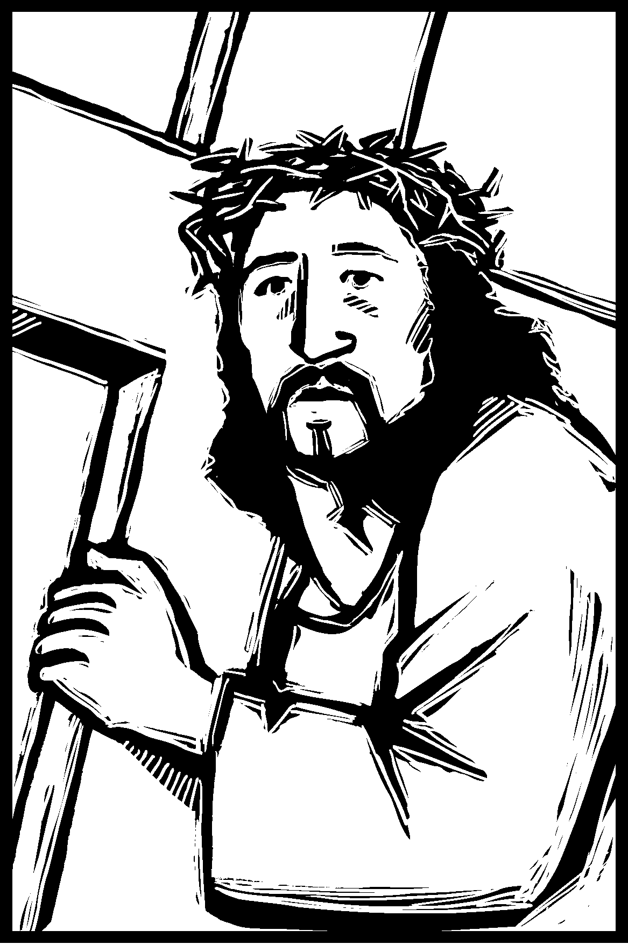
What does the devil want to do to us?

"Your enemy the devil prowls around like a roaring lion looking for someone to devour." (I Peter 5:8)

Why did the devil want to ruin Christmas?

"[Mary] will give birth to a son, and you are to give him the name Jesus, because he will save his people from their sins." (Matthew 1:20)

What did Jesus do to the devil?

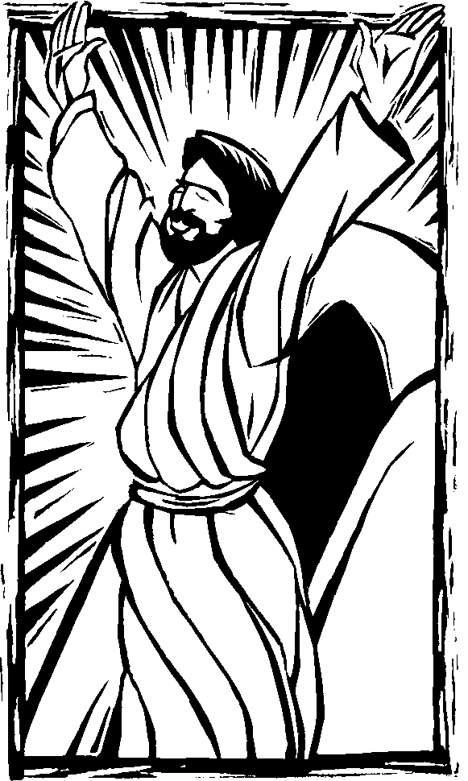
Since the children have flesh and blood, he too shared in their humanity so that by his death he might destroy him who holds the power of death—that is, the devil— and free those who all their lives were held in slavery by their fear of death. (Hebrews 2:14-15)

What does Jesus’ victory over the devil mean for us? Do we have to be afraid of him?



