NAME ________________________________

What is a holiday?

Make a list of some of the holidays we celebrate every year.
Circle your favorite holiday.

People use the word “holiday” to describe just about any special occasion that our country celebrates (and we get school off for!). But did you know the word “holiday” used to mean something even more special than that? The word “holiday” is a combination of two words. Fill in the blanks below with those two words.

____ ____ ____ ____ - ____ ____ ____

What does the word “holy” mean?

How can a day be holy?

Using a colored marker or crayon, circle the holidays you wrote down above which are set aside from other days of the year to celebrate what God has done for us.
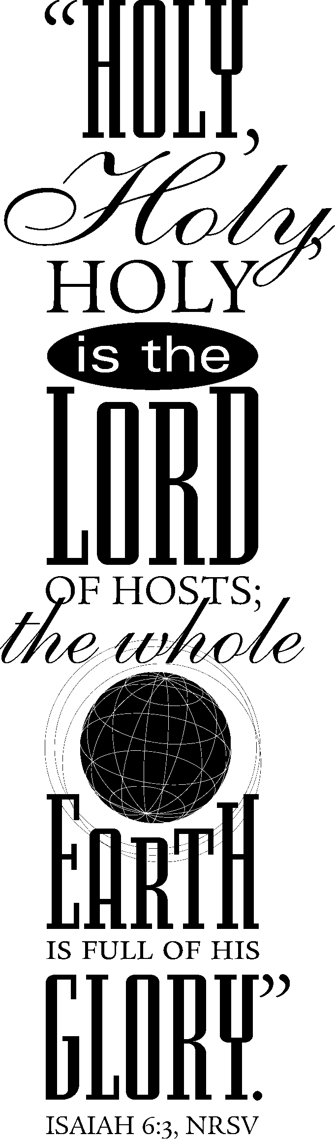
GOD IS HOLY

Who alone is holy all by himself?

“Holy, holy, holy is the LORD Almighty; the whole earth is full of his glory.”
(Isaiah 6:3)

Does the fact that God is holy fill you with comfort and make you happy or does it make you a little afraid? Why?

Since God is holy, what will he never do against you?

“When tempted, no one should say, ‘God is tempting me.’ For God cannot be tempted by evil, nor does he tempt anyone.”
(James 1:13)

“It is impossible for God to lie.”
(Hebrews 6:18)

“If we are faithless, he will remain faithful, for he cannot disown himself.”
(2 Timothy 2:13)

YOU ARE NOT HOLY

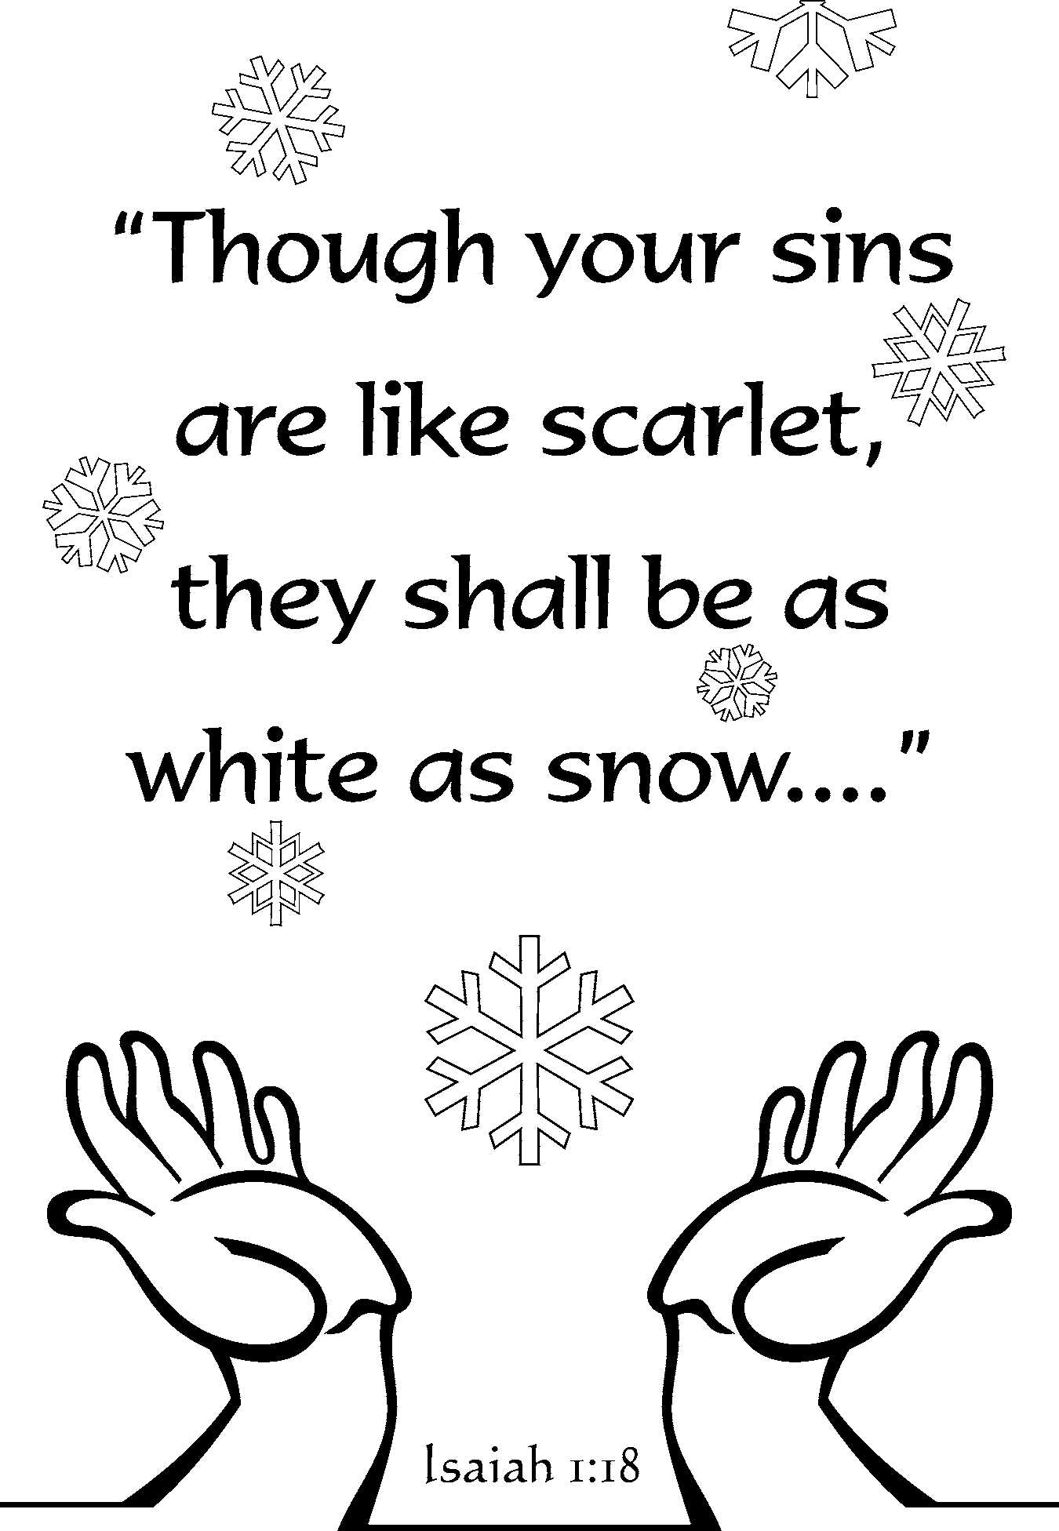
What does God expect you to be?

“Be holy because I, the LORD your God, am holy.”
(Leviticus 19:2)

What do we call it when we fail to be holy?

“All have sinned and fall short of the glory of God.”
(Romans 3:23)

What is the consequence of our failure to be holy?

“The wages of sin is death.”
(Romans 6:23)

God loves us so much that instead of making us suffer the consequences of our sins, he promised to send a Savior. What would he do?

"[Mary] will give birth to a son, and you are to give him the name Jesus, because he will save his people from their sins."

(Matthew 1:20)

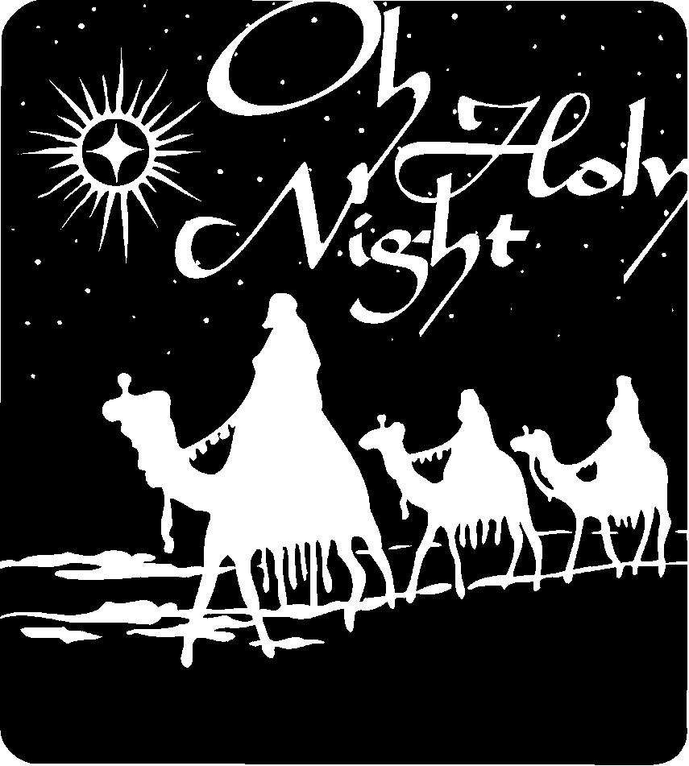
JESUS IS HOLY

God kept his promise to send us a Savior to rescue us from our sins. Listen to the account of the night Jesus was born.

Luke 2:4-20

4 So Joseph also went up from the town of Nazareth in Galilee to Judea, to Bethlehem the town of David, because he belonged to the house and line of David. 5 He went there to register with Mary, who was pledged to be married to him and was expecting a child. 6 While they were there, the time came for the baby to be born, 7 and she gave birth to her firstborn, a son. She wrapped him in cloths and placed him in a manger, because there was no room for them in the inn.

8 And there were shepherds living out in the fields nearby, keeping watch over their flocks at night. 9 An angel of the Lord appeared to them, and the glory of the Lord shone around them, and they were terrified. 10 But the angel said to them, "Do not be afraid. I bring you good news of great joy that will be for all the people. 11 Today in the town of David a Savior has been born to you; he is Christ the Lord. 12 This will be a sign to you: You will find a baby wrapped in cloths and lying in a manger."
13 Suddenly a great company of the heavenly host appeared with the angel, praising God and saying, 14 "Glory to God in the highest, and on earth peace to men on whom his favor rests."
15 When the angels had left them and gone into heaven, the shepherds said to one another, "Let's go to Bethlehem and see this thing that has happened, which the Lord has told us about." 16 So they hurried off and found Mary and Joseph, and the baby, who was lying in the manger. 17 When they had seen him, they spread the word concerning what had been told them about this child, 18 and all who heard it were amazed at what the shepherds said to them. 19 But Mary treasured up all these things and pondered them in her heart.
20 The shepherds returned, glorifying and praising God for all the things they had heard and seen, which were just as they had been told.
JESUS IS HOLY

Jesus is the only One who could have ever been our Savior. Why? What was so special about him?


“The angel answered [Mary], ‘The Holy Spirit will come upon you, and the power of the Most High will overshadow you. So the holy one to be born will be called the Son of God.’”
(Luke 1:35)

“We have one [a Savior] who has been tempted in every way, just as we are – yet was without sin.”
(Hebrews 4:15)

“Such a high priest meets our need – one who is holy, blameless, pure, set apart from sinners, exalted above the heavens.”
(Hebrews 7:26)
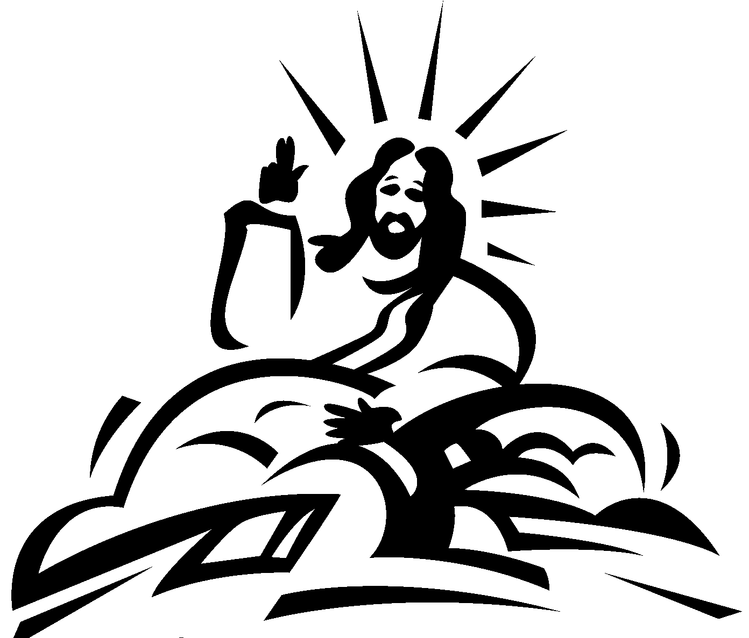
What kind of a life did Jesus live?

Why is this so important? Who did he do this for?

JESUS MAKES YOU HOLY

Why was Jesus born? What did he come to do for us?


“We have been made holy through the sacrifice of the body of Jesus Christ once for all.”
(Hebrews 10:10)

How did he do that?

“By one sacrifice he has made perfect forever those who are being made holy.”
(Hebrews 10:14)

“Christ loved the church and gave himself up for her to make her holy, cleansing her by the washing with water through the word, and to present her to himself as a radiant church, without stain or wrinkle or any other blemish, but holy and blameless.”
(Ephesians 5:25-27)

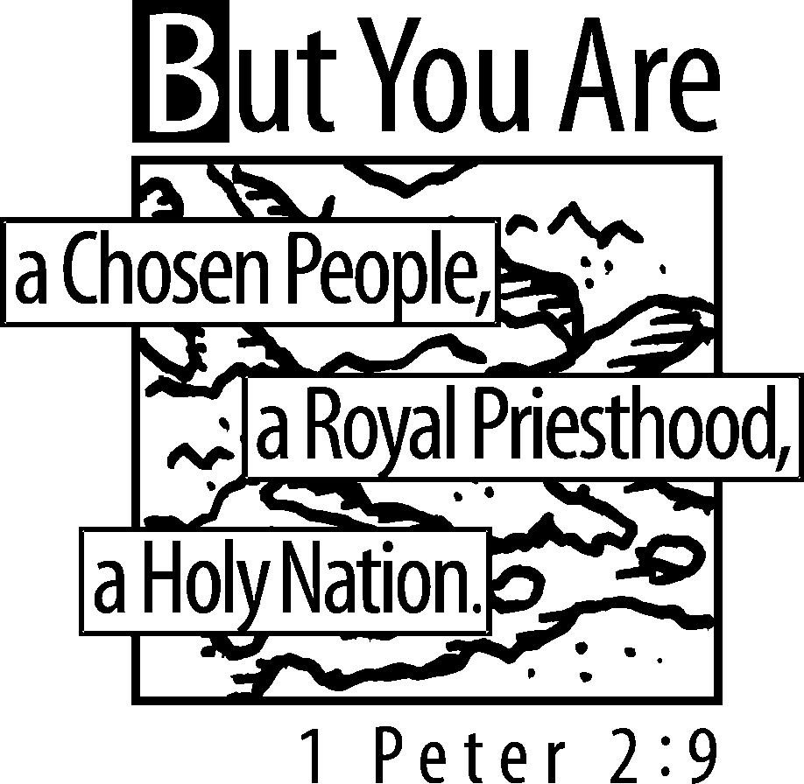
Why did he do that?

“God save us and called us to a holy life – not because of anything we have done but because of his own purpose and grace.”
(2 Timothy 1:9)

JESUS MAKES EVERY DAY HOLY

“I am the LORD, who makes you holy.”
(Exodus 31:13)

Since God took away all of your sins and had Jesus suffer for them – and since God has led you to believe that – what does God think of you and how does he treat you?

On what days are you holy?
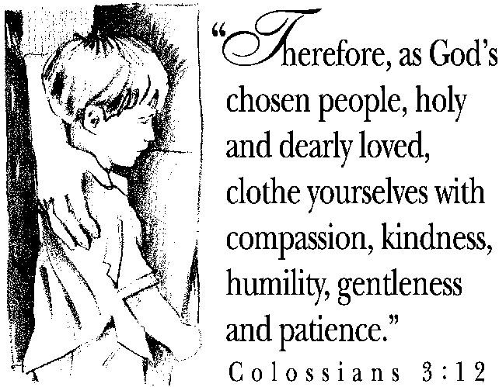

So how many days are “holy-days” for you?

How many “holy-days” will you have with God because of Jesus?

“Blessed and holy are those who have part in the first resurrection. The second death has no power over them.”
(Revelation 20:6)

How will we want to live our lives every day in thanks to God for making us holy?

“In view of God’s mercy, offer your bodies as living sacrifices, holy and pleasing to God.”
(Romans 12:1)

