Silent night! Holy night! All is calm, all is bright. ‘Round yon Virgin Mother and Child, Holy infant so tender and mild, Sleep in heavenly peace, Sleep in heavenly peace.

Silent night! Holy night!
Shepherds quake at the sight.
Glories streams from heaven afar;
Heav’nly hosts sing, Alleluia;
Christ, the savior is born!
Christ the Savior is born!

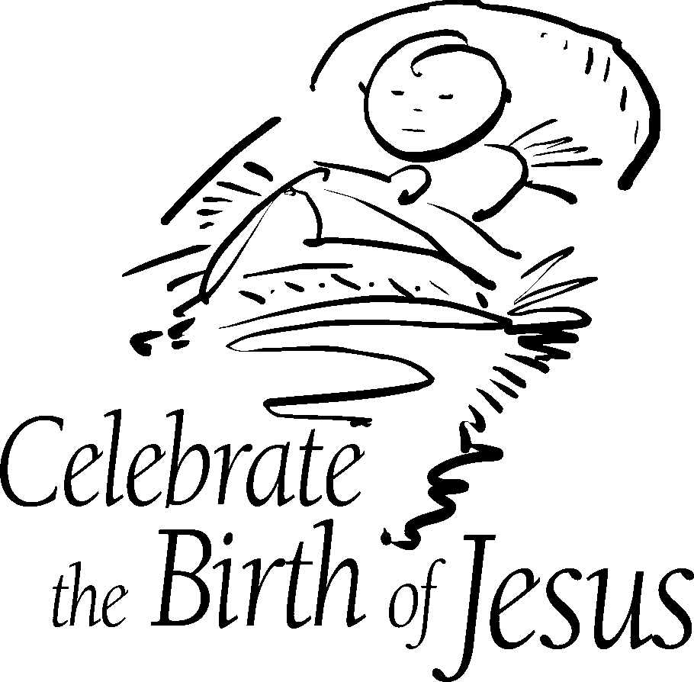

Joy to the world , the Lord has come!
Let earth receive her king.

Let ev’ry heart prepare him room
And heav’n and nature sing,
And heav’n and nature sing,
And heav’n, and heav’n and nature sing.

Joy to the earth, the Savior reigns!
Let all their songs employ,
While fields and floods, rocks, hills and plains
Repeat the sounding joy,
Repeat the sounding joy,
Repeat, repeat, the sounding joy

He rules the world with truth and grace

And makes the nations prove
The glories of his righteousness
And wonders of his love,
And wonders of his love,
And wonders, wonders of his love

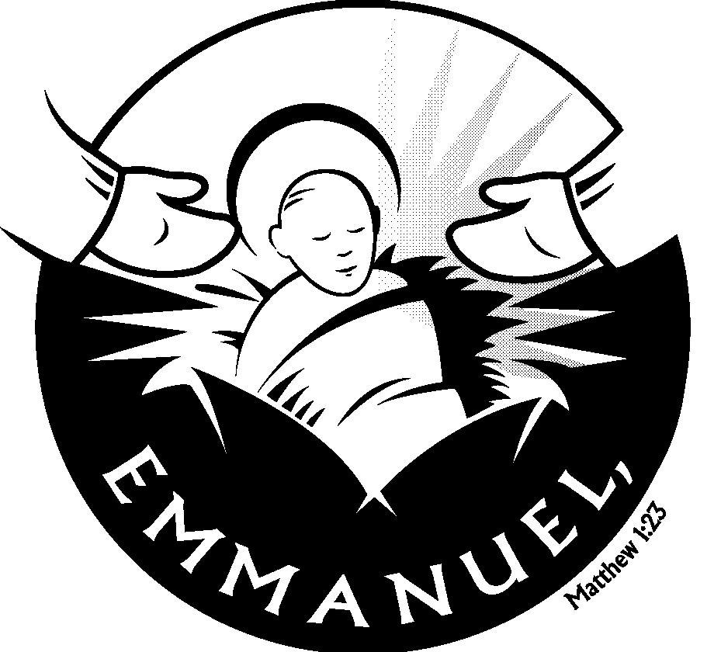

O come, all ye faithful,
Joyful and triumphant,
O come ye, o come ye
To Bethlehem;
Come and behold Him
Born the King of angels:
O come, let us adore Him,
O come, let us adore Him,
O come, let us adore Him,
Christ the Lord.

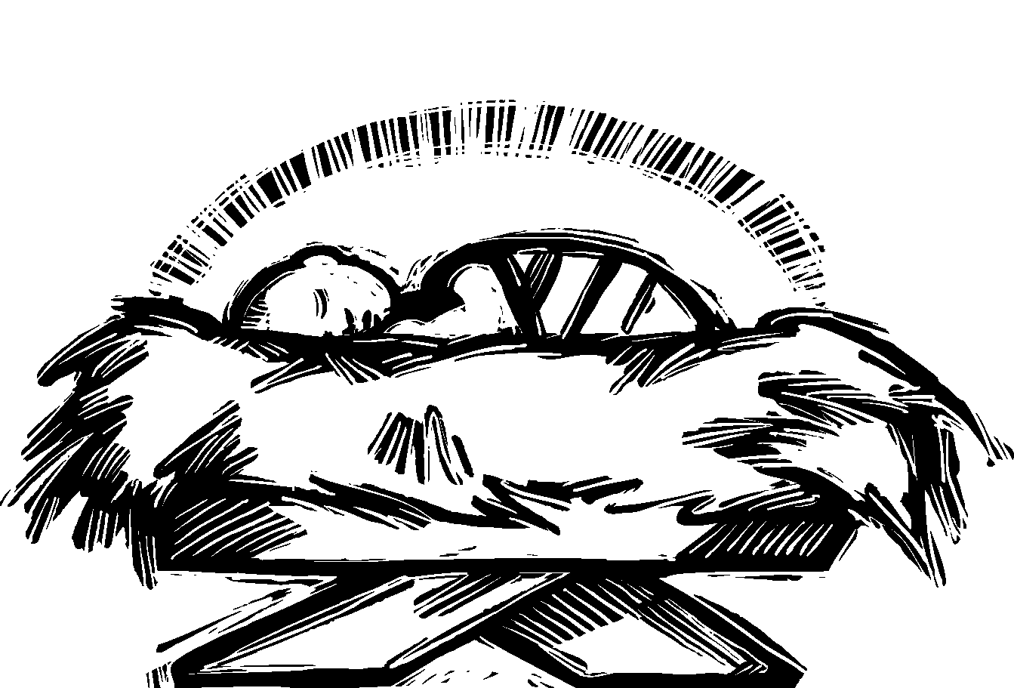

Away in a manger, no crib for a bed,
The little Lord Jesus laid down his sweet head.
The stars in the sky looked down where He lay,
The little Lord Jesus asleep on the hay.

The cattle are lowing, the poor Baby wakes,
But little Lord Jesus no crying He makes.
I love thee, Lord Jesus looked down from the sky,
And stay by my cradle till morning is nigh.

The first Noel, the angels did say,
Was to certain poor shepherds in fields as they lay;
In fields where they lay; keeping their sheep
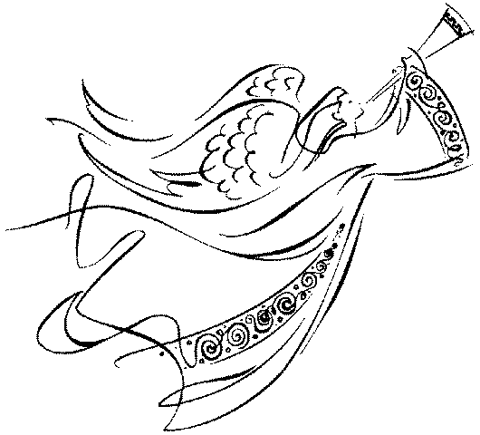
On a cold winter’s night that was so deep.
Noel, Noel, Noel, Noel,
Born is the King of Israel.
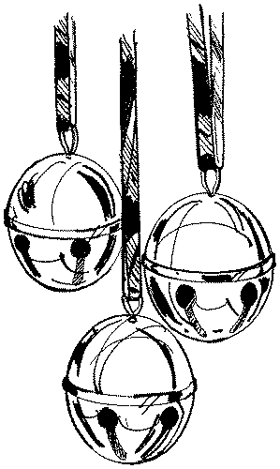

Dashing through the snow
in a one-horse open sleigh;
O’er the fields we go laughing all the way.
Bells on bobtail ring making spirits bright;
What fun it is to ride and sing
a sleighing song tonight!

Jingle bells, jingle bells, jingle all the way,
Oh, what fun it is to ride
in a one-horse open sleigh!
Jingle bells, jingle bells, jingle all the way,

Oh, what fun if is to ride in a one-horse open sleigh!
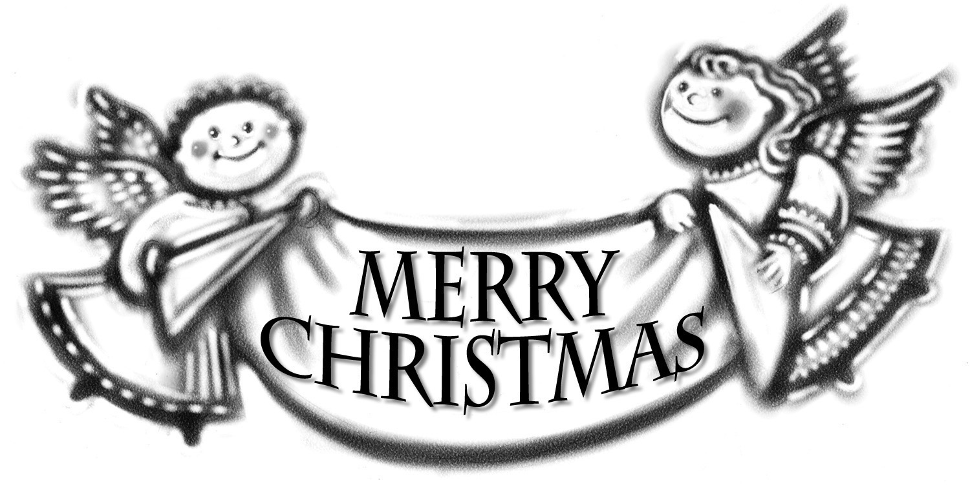

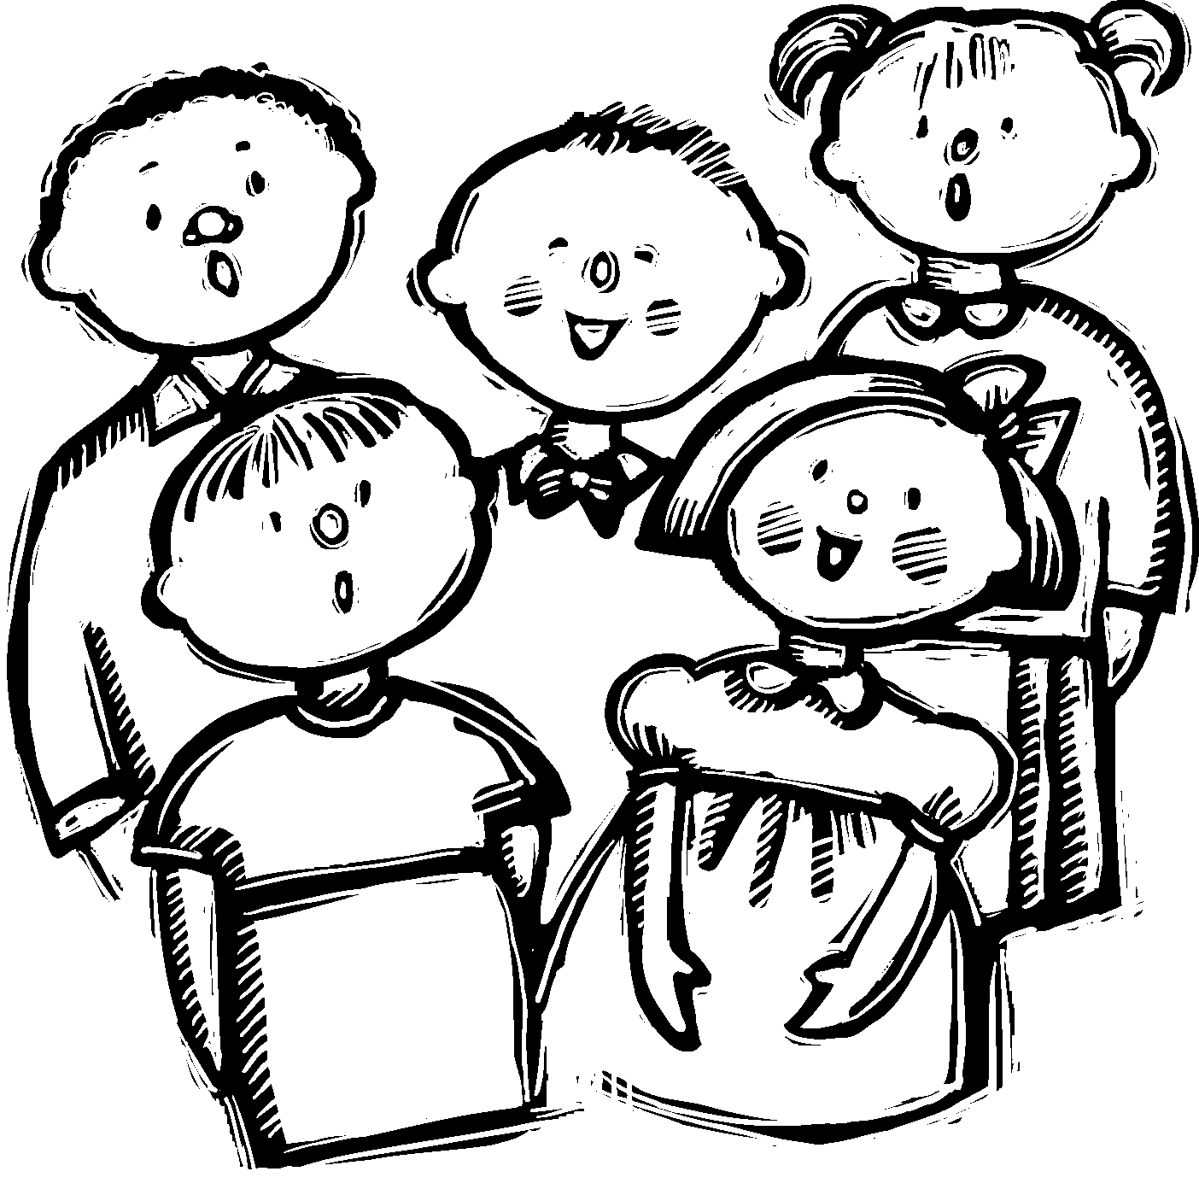

Christmas for Kids 2006
Songbook

Water of Life Lutheran Church

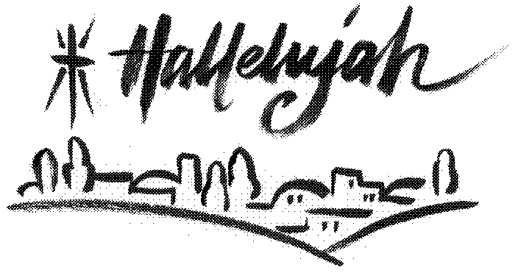

O Little Town of Bethlehem, How still we see thee lie!
Above thy deep and dreamless sleep
The silent stars go by.
Yet in thy dark streets shineth The everlasting light.
The hopes and fears of all the years
Are met in thee tonight.

For Christ is born of Mary, And gathered all above,
While mortals sleep, the angels keep
Their watch of wond’ring love.
O morning stars, together Proclaim the holy birth,
And praises sing to God the King
And peace to all the earth.

O holy Child of Bethlehem, Descend to us, we pray;
Cast out our sin and enter in; Be born in us today.
We hear the Christmas angels The great glad tidings tell;
Oh, come to us, Abide with us, Our Lord Immanuel!

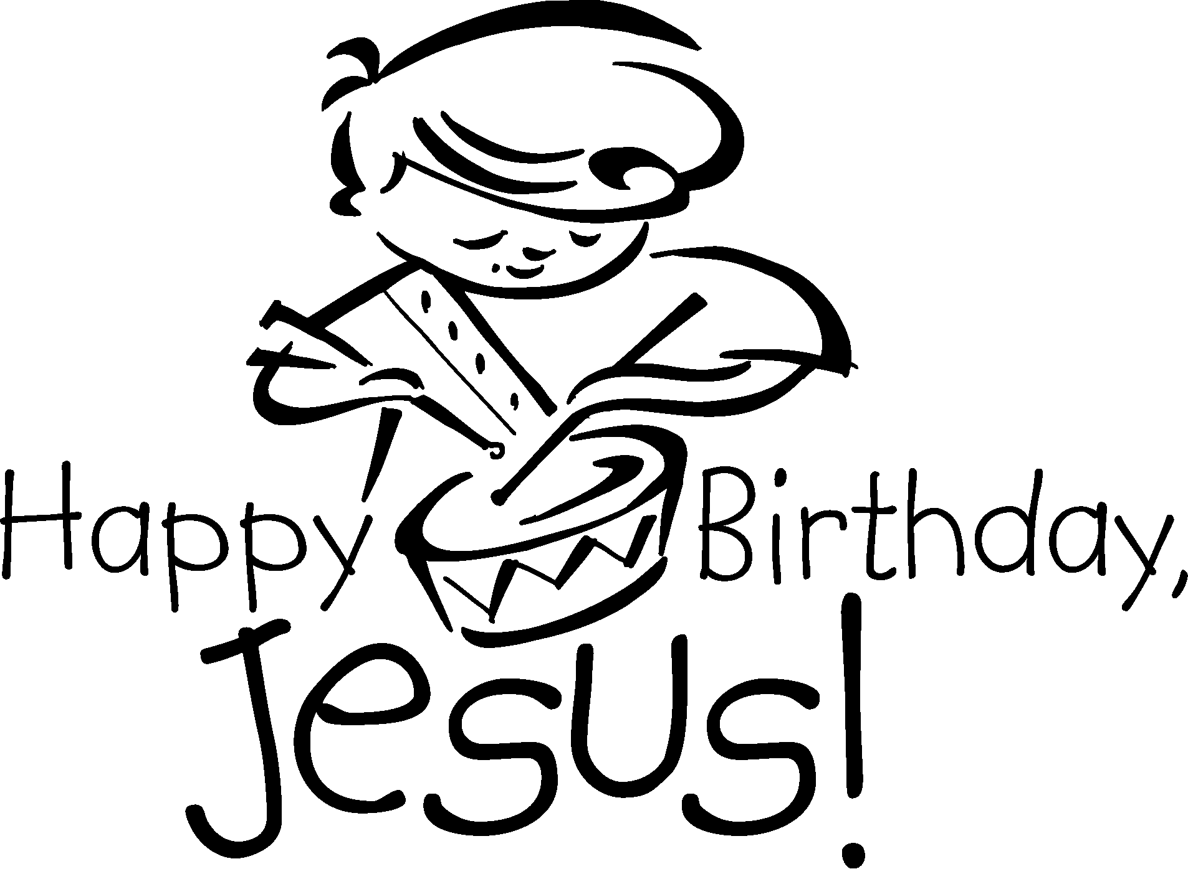

Little Drummer Boy

Come, they told me, Pa-rum-pum-pum-pum -
A newborn King to see; Pa-rum-pum-pum-pum -
Our finest gifts we bring, Pa-rum-pum-pum-pum -
To lay before the King, Pa-rum-pum-pum-pum, rum-pum-pum-pum, rum-pum-pum-pum -
So to honor Him, Pa-rum-pum-pum-pum -
When we come.

I played my drum, Pa-rum-pum-pum-pum -
The ox and lamb kept time; Pa-rum-pum-pum-pum
I played my drum for Him, Pa-rum-pum-pum-pum -
I played my best for Him, Pa-rum-pum-pum-pum, rum-pum-pum-pum, rum-pum-pum-pum -
Then He smiled at me, Pa-rum-pum-pum-pum -
Me and my drum.

O Come, Little Children

O come, little children, O come, one and all,
O come to the manger in Bethlehem's stall,
And see the Lord Jesus asleep in the hay,
The little Lord Jesus was born Christmas Day.

Now "Glory to God" comes the song from on high,
And "Peace for all mankind!" we sing in reply,
Then come, little children, be happy and say,
That Jesus, the Christ Child, was born Christmas Day.

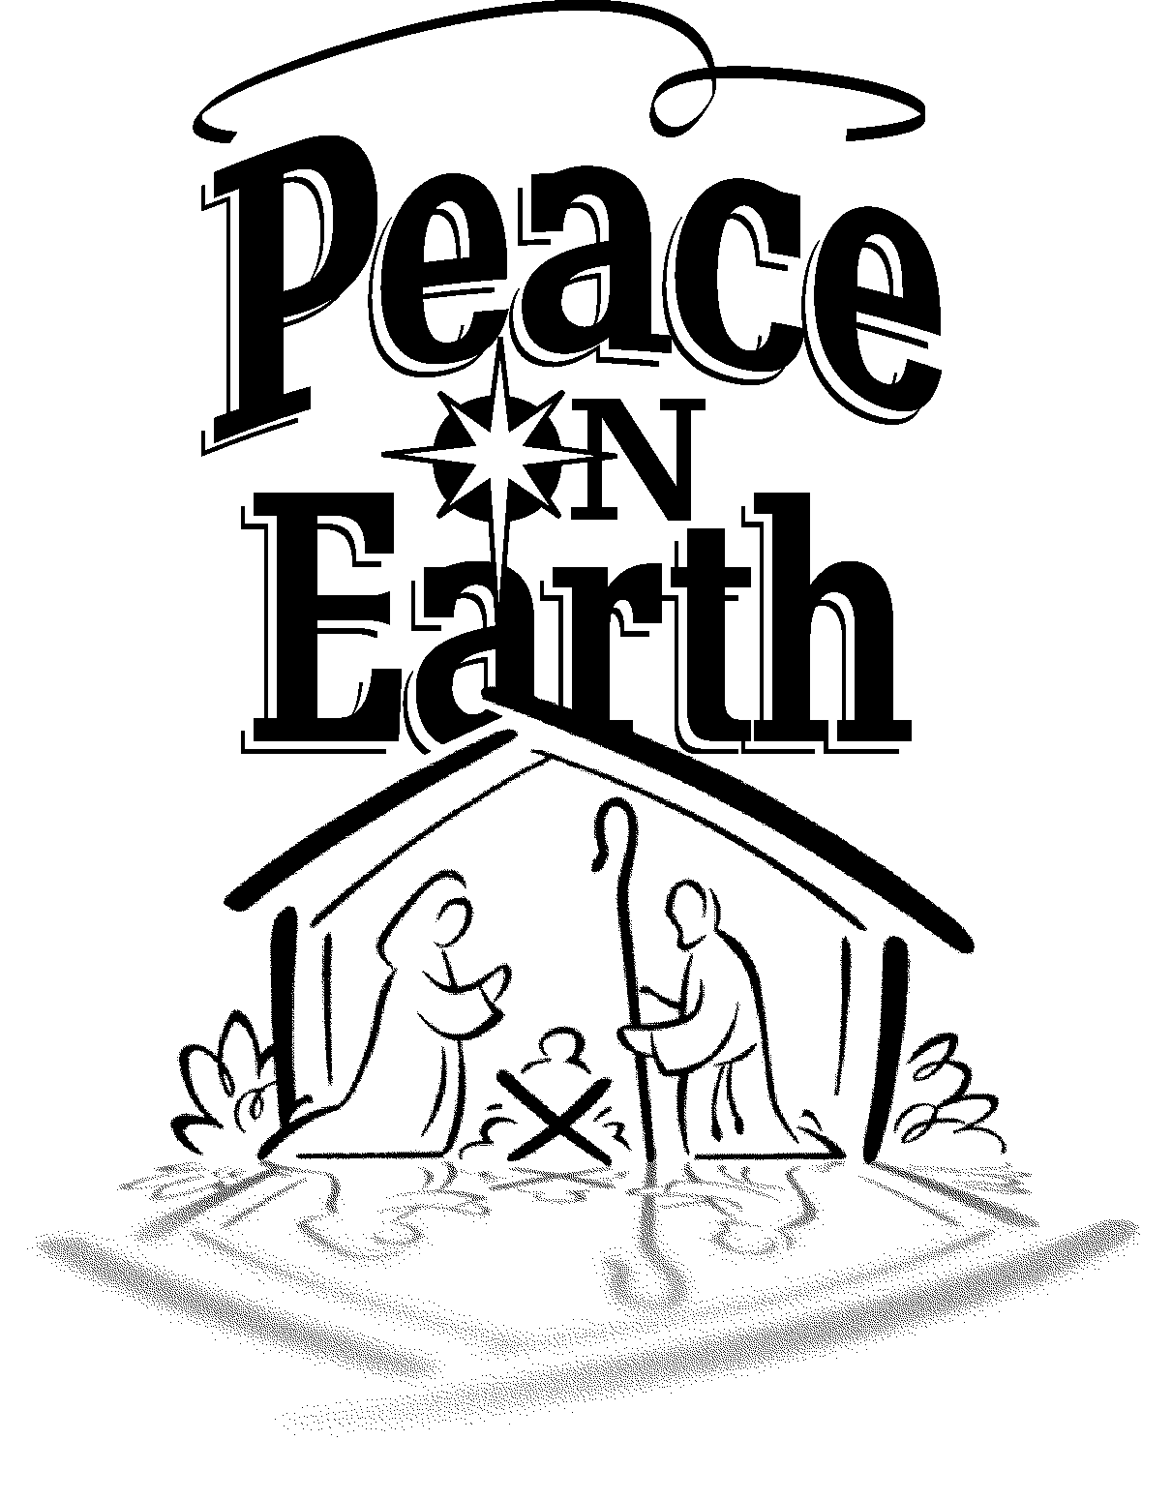

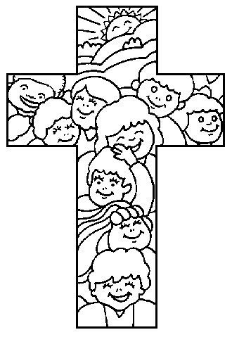

As each happy Christmas

Dawns on earth again,

Comes the holy Christchild

To the hearts of men.

Enters with his blessing

Into ev’ry home,

Guides and guards our footsteps

As we go and come.

All unknown, beside me

He will ever stand,

And will safely lead me

With his own right hand.

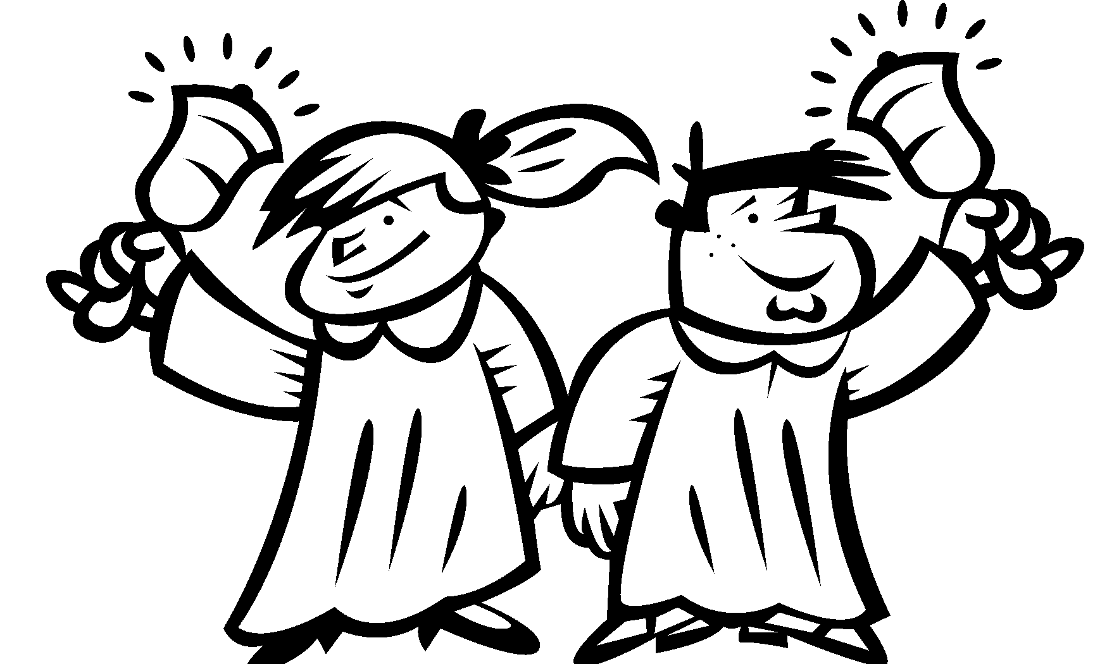

Ring the Bells
(To the tune of “Jingle Bells”)

Ring the bells, Ring the bells, Ring the bells today.
Jesus came, Jesus came
For us on Christmas Day.

Ring the bells, Ring the bells, Ring the bells today.
Jesus came, Jesus came
To take our sins away.

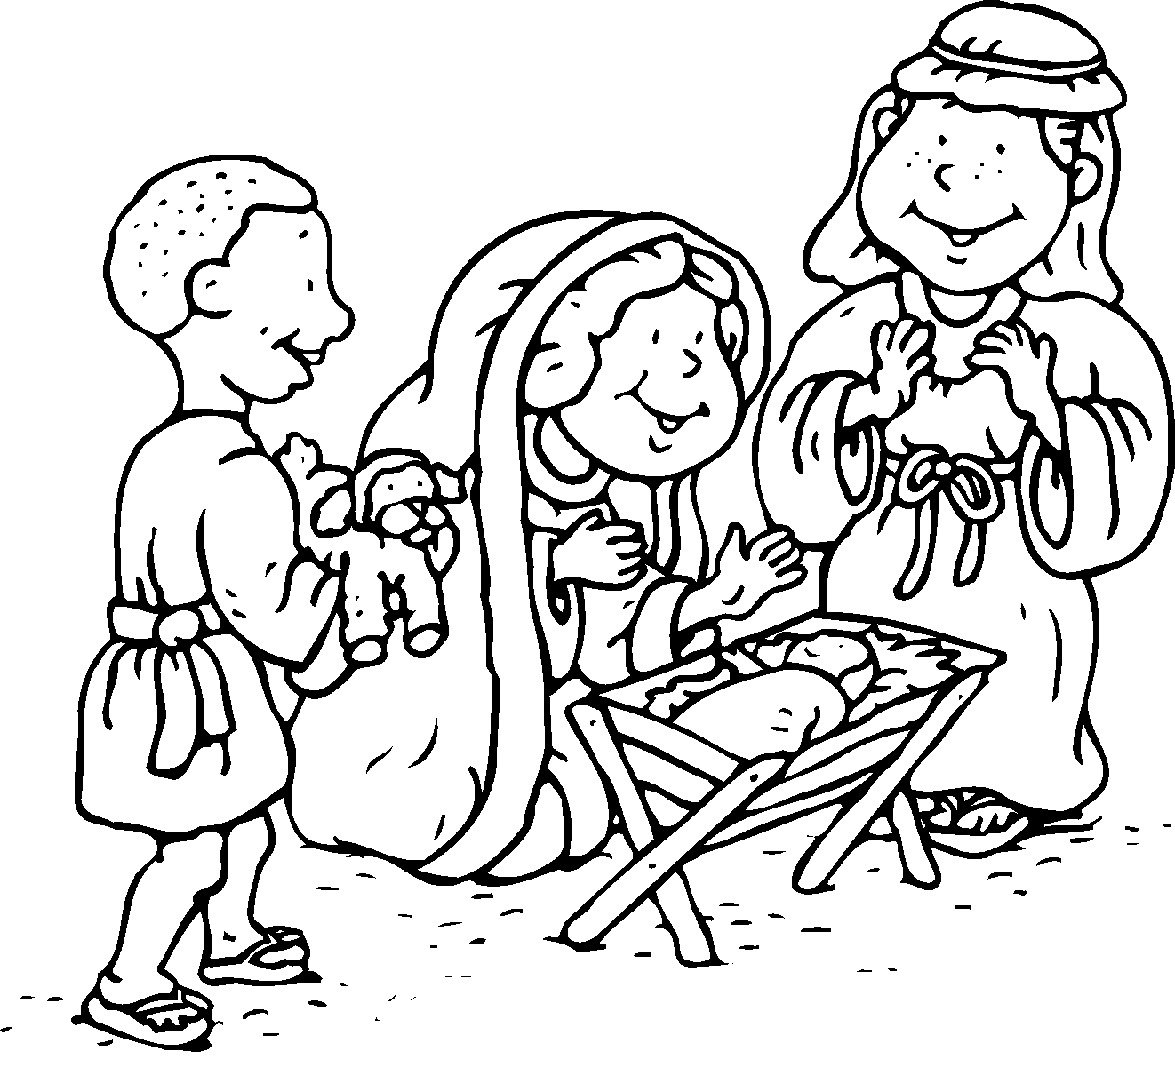

Christ was Born in Bethlehem
(To the tune of “Michael, Row the Boat Ashore”)

Christ was born in Bethlehem, Alleluia!
Born to save us from our sin. Alleluia!

Songs of joy the angels sang. Alleluia!
To see Jesus, shepherds ran. Alleluia!

Every gift and every boy. Alleluia!
Join us in our song of joy. Alleluia!

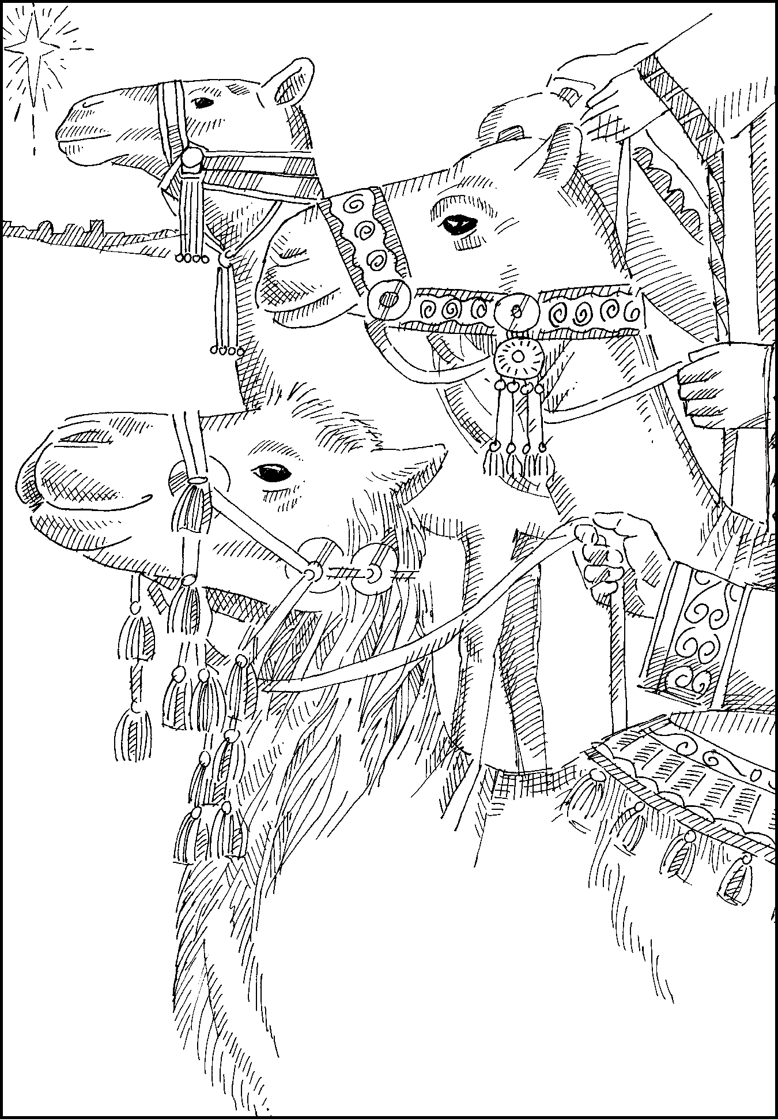

Look in the Sky
(To the tune of “Up on the Housetop”)

“Look in the sky!” the Wise Men say.
“See the star that leads the way.
We will follow it to the King;
Gifts to give Him let us bring.”

Bumpety bump! Bumpety bump!
Riding on the camel’s hump.
Over the desert sand they ride,
Till they reach the Savior’s side.

